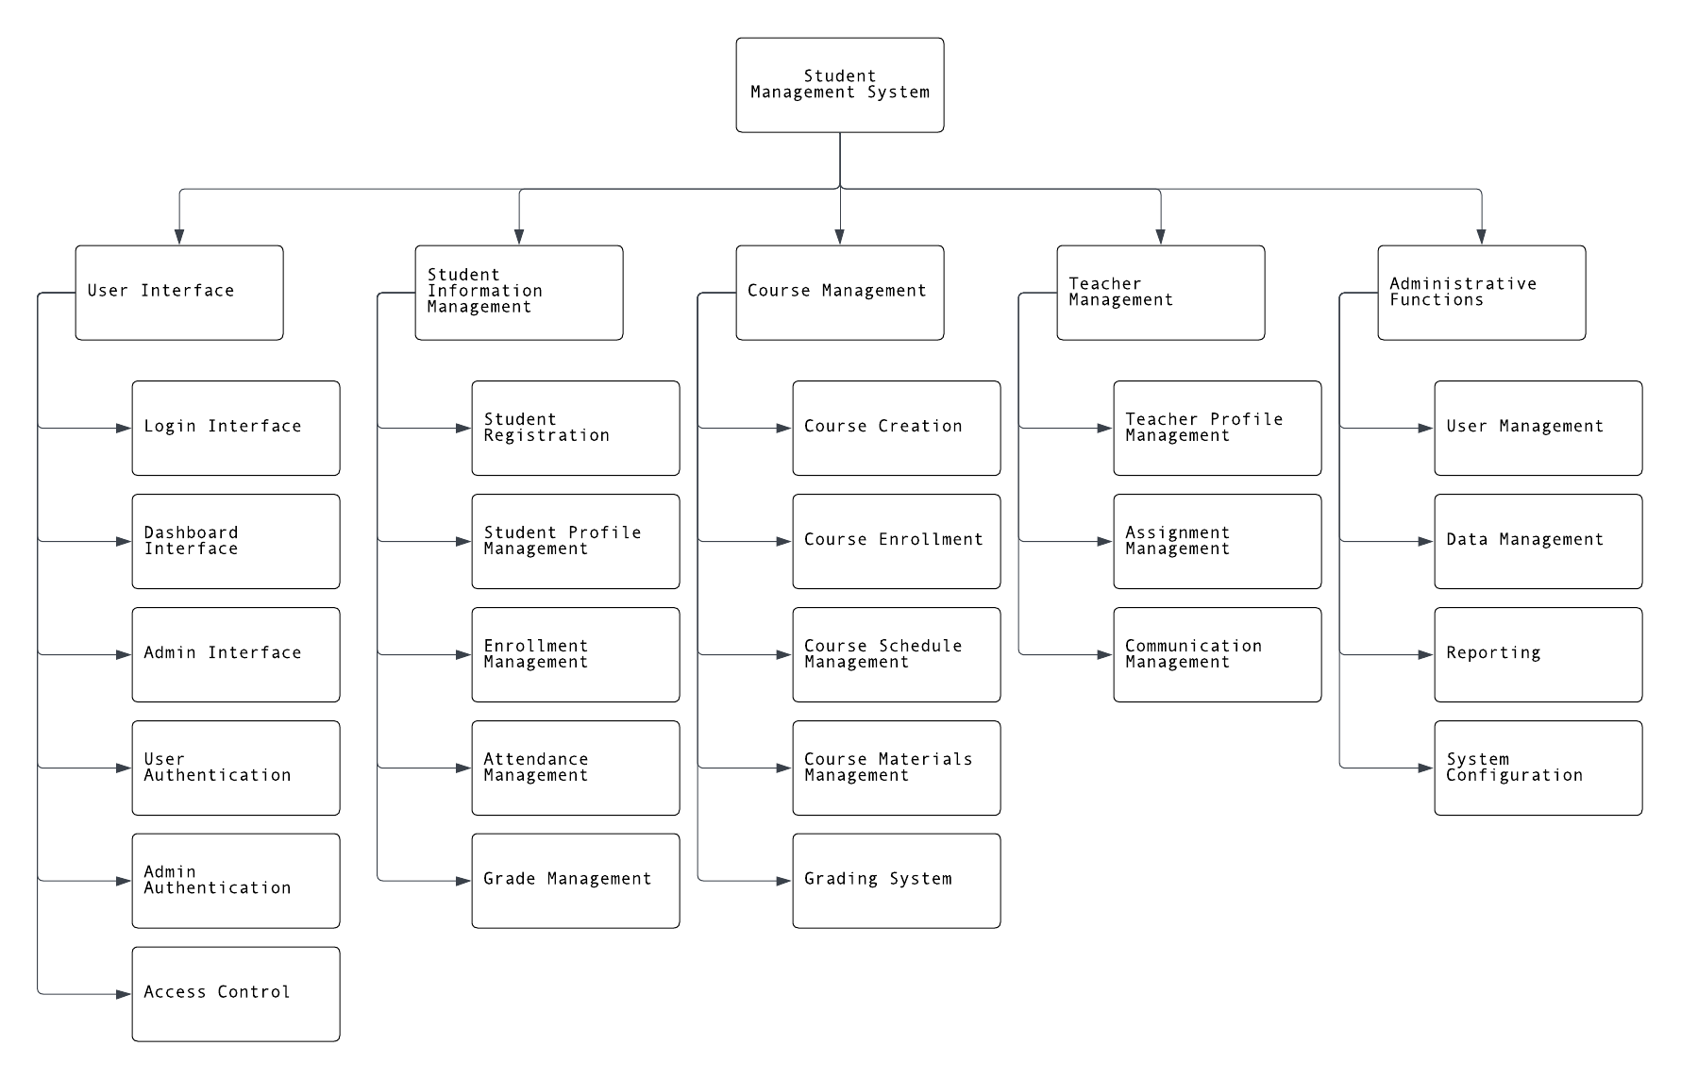 **Functional Decomposition Diagram**

**Functional Decomposition List**

1.0 Student Management System

1.1 User Interface

1.1 Login Interface

1.2 Dashboard Interface

1.3 Admin Interface

1.4 User Authentication

1.5 Admin Authentication

1.6 Access Control

* 1. Student Information Management

2.1 Student Registration

2.2 Student Profile Management

2.3 Enrollment Management

2.4 Attendance Management

2.5 Grade Management

1.3 Course Management

3.1 Course Creation

3.2 Course Enrollment

3.3 Course Schedule Management

3.4 Course Materials Management

3.5 Grading System

1.4 Teacher Management

4.1 Teacher Profile Management

4.2 Assignment Management

4.3 Communication Management

1.5 Administrative Functions

5.1 User Management

5.2 Data Management

5.3 Reporting

5.4 System Configuration